# CS 255 System Design Document Template

This template lays out all the different sections that you need to complete for Project Two. Each section has guidance to prompt your thinking. You will need to continually reference the interview transcript as you work to make sure that you are addressing your client’s needs. There is no required length for the final document. Instead the goal is to complete each section based on what your client’s needs are. Remove this note when you are finished, and replace all bracketed text with the relevant information.

## UML Diagrams

### UML Use Case Diagram

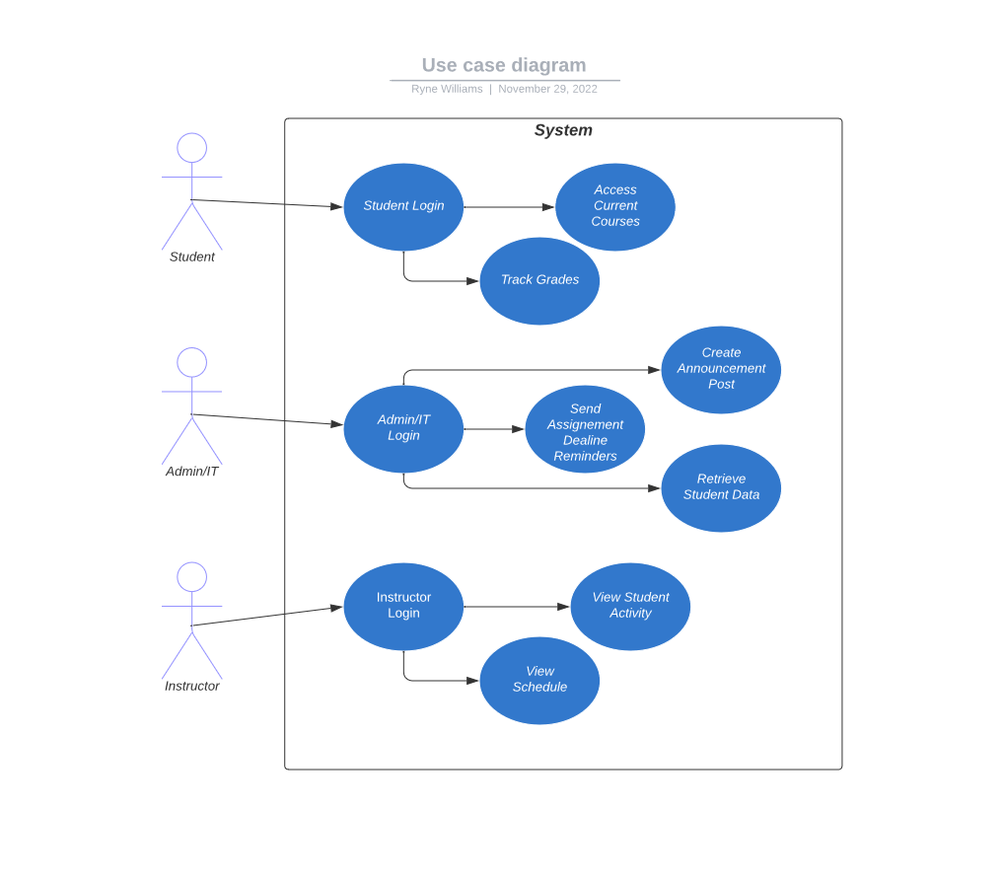

### UML Activity Diagrams

### UML Sequence Diagram

### UML Class Diagram

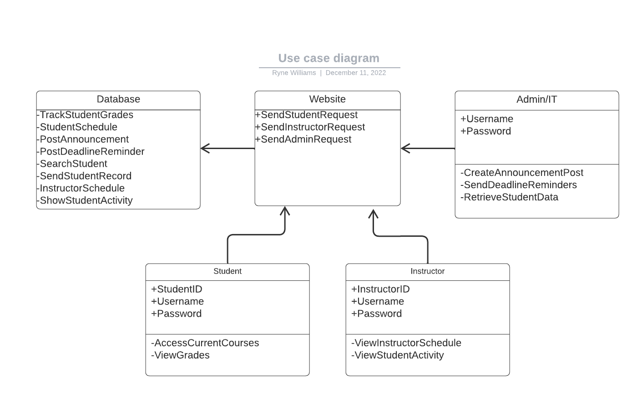

## Technical Requirements

This system should operate on all web-based browsing platforms and all computer operating systems. The database for this system should use a server to store all user and system data and variables. Updates to the system should be sent through the database. Students, instructors, and Admin/IT will create a unique username, as well as setting a password, when setting up their online account. Students will only have access to their courses, grades, and instructor comments. Instructors will be able to view their teaching schedule and access student grading information to input grades. Admin/IT will have access to view student and instructor data, as well as saving that data to their computer, and will have access to post announcements and assignment deadline reminders. Admin/IT will also have access to modify, delete, or reset student and instructor accounts.